Project Title: Austin Housing Price Indicators

Team Members: Hannah Fan, Evert Lizama, Chris Reid, Miko Laforteza

UT-Data Analysis Bootcamp April 2018

6/14/2018

**Project Statement:**

Our project is to uncover patterns in housing prices around Austin. We'll examine relationships between housing prices and initial indicators of “gentrification” including: construction permits, affordable housing inventory, density of parks, and trends in crime rates over the course of the different years; and related questions, as the data admits.

**How does housing prices change between 2012-2018 per zip code?**

Description:

The graph below shows the housing price changes for each zipcode over the course of the years 2012-2018. It is observed of a general increase in housing prices across all zipcodes.

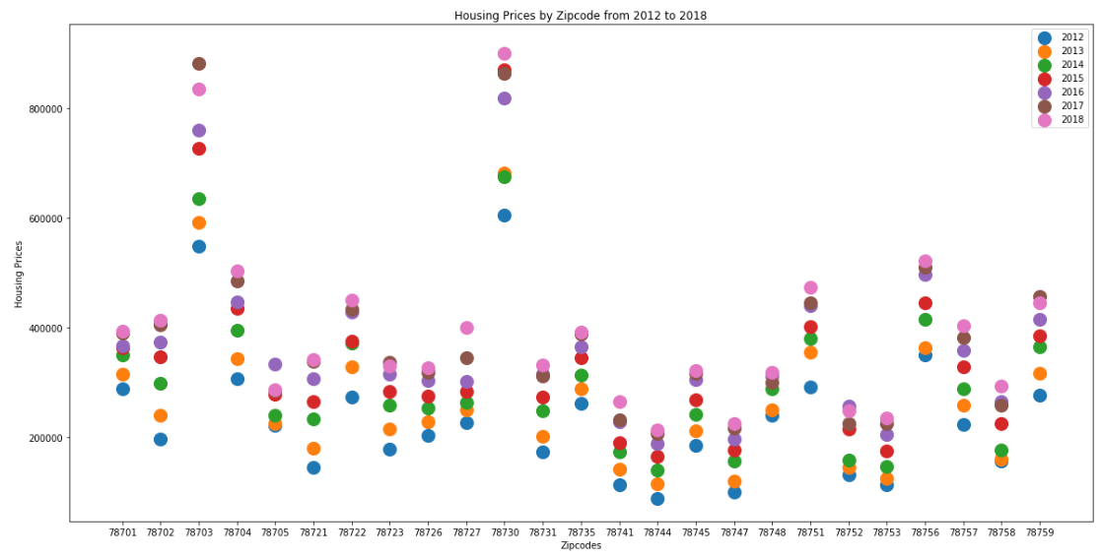

**How does the number of construction permits issued over the years affect housing prices?**

Description:

In the graph below, the graph maps that the number of permits being issued increases over the years of 2012 to 2018. It is understanding that with greater amount of permits issued, there is a greater investment in the overall Austin region, and an increase in housing prices.

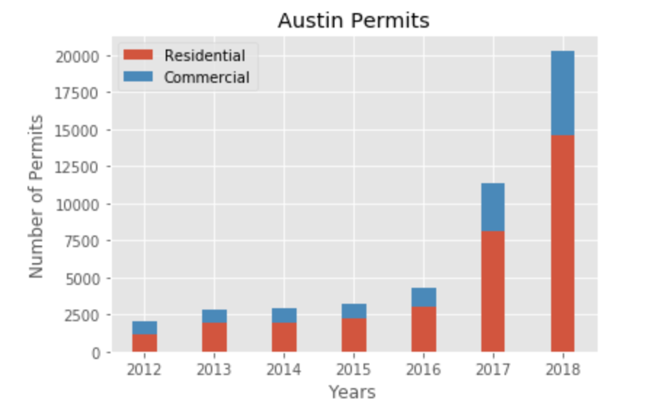

**How does the number of construction permits per zip code issued affect housing prices over the years?**

Description:

The graph below visualizes the the data for zip codes and the number of construction permits issued. Unsurprisingly, the zip codes that experienced a higher number of construction permits experienced a higher rise in housing price.

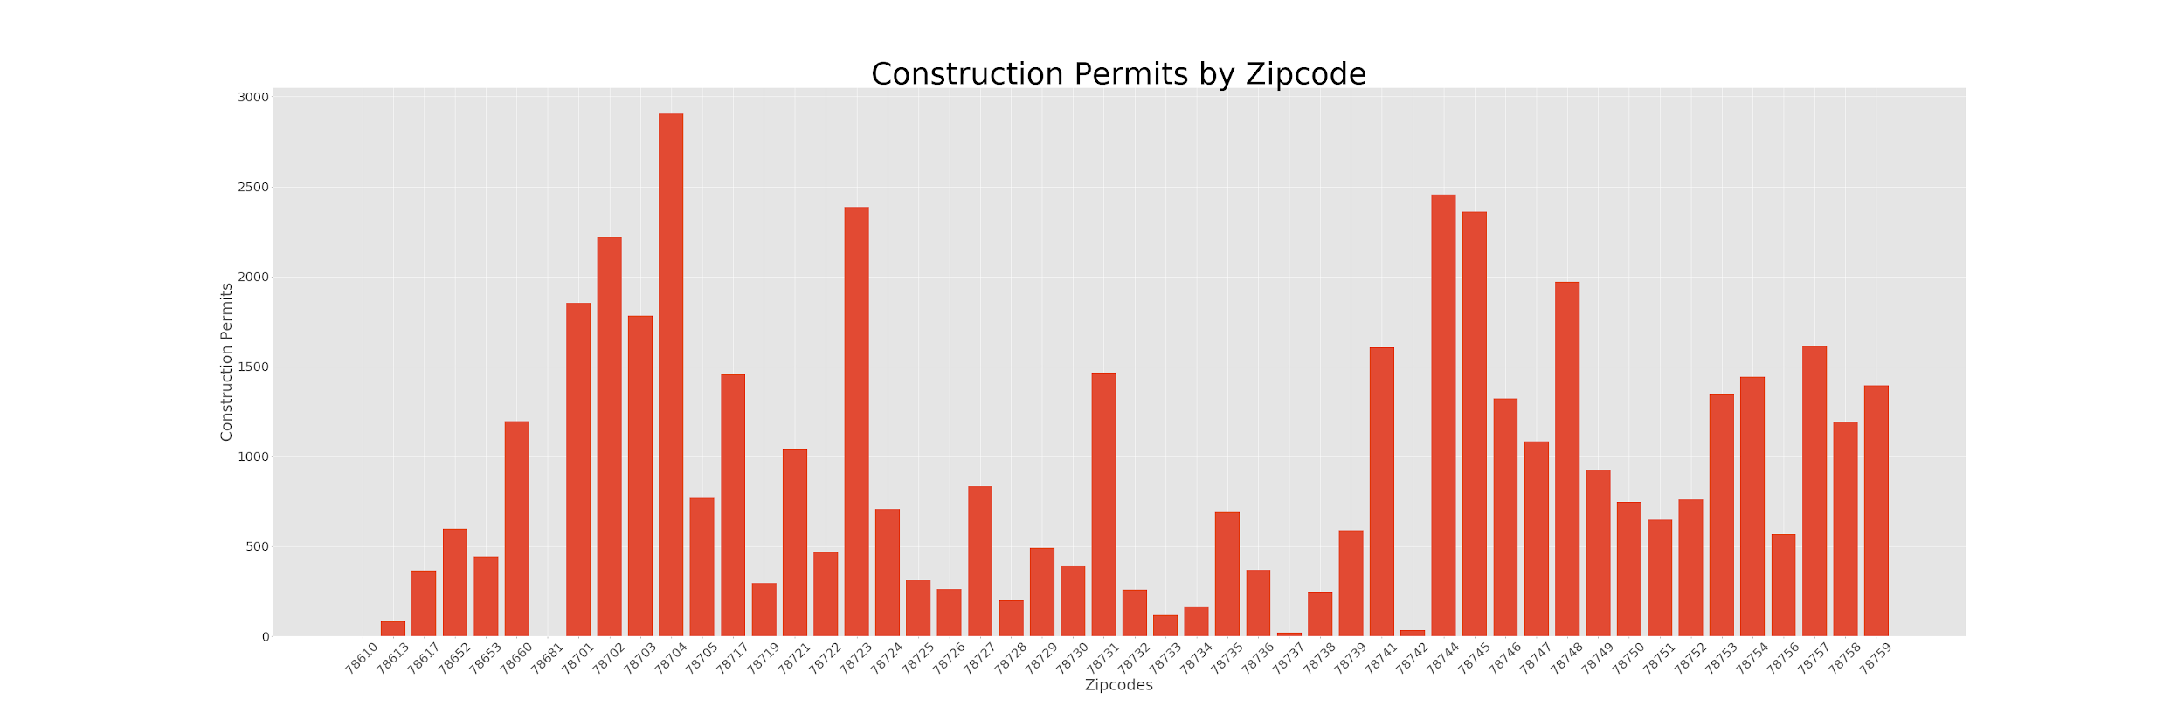

**How does the number of demolitions affect housing prices over the years?**

Description:

The zipcodes with the highest number of demolitions show a positive correlation with the highest change in housing prices. It is the understanding from the data that the zipcodes with the greatest number of demolition permits correlate with greater activity and reinvestment into a certain area.

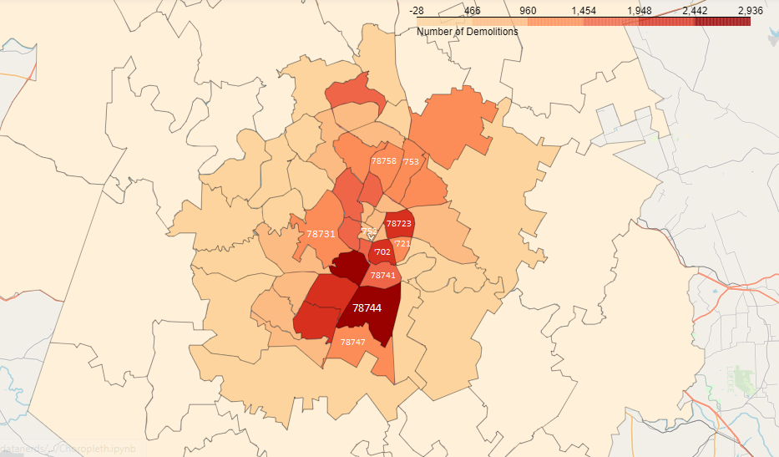

**How does housing prices affect the number of affordable units affect housing prices over the years?**

Description:

The Affordable Housing Inventory dataset includes all income-restricted affordable units in developments funded through the Rental Housing Development Assistance Program, fthe Acquisition and Development Program and various Development Incentive Programs. In order to correspond with housing price dataset, the projects within the AHI that were focused on were limited to completed projects within 2012-2018.

Analysis:

Another factor we took into consideration is affordable housing in Austin. The reason being is that affordable housing data can be a good indicator of housing prices relative to the area. In this case, I was responsible for gathering Austin affordable housing inventory that included all income-restricted affordable units in development or completed.

For this dataset, my approach I took was first understanding the important data points that could be relevant to our analysis which was the zip code, housing type, and median family income. I then cleaned the dataset to remove rows with missing data such as the zip code.

For the bar graphs, the team and I were able to find a relationship between affordable housing availability by zip codes here that have been marked with the blue box over it. We were able determine that in the areas where the housing affordability was low there was a significant increase in housing pricing as well as building permits which would drive housing affordability down.

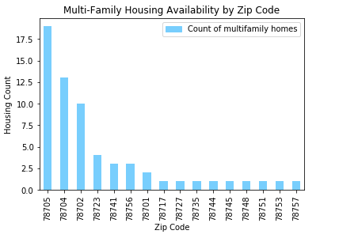 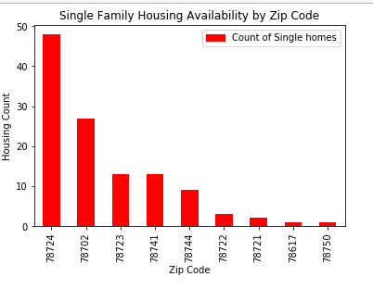

**How does housing prices affect the allocation of median family income?**

Description:

The Affordable Housing Inventory dataset includes all income-restricted affordable units in developments funded through the Rental Housing Development Assistance Program, fthe Acquisition and Development Program and various Development Incentive Programs. In order to correspond with housing price dataset, the projects within the AHI that were focused on were limited to completed projects within 2012-2018.

Analysis:

In the chart below, the figure confirms that a large percentage of families allocate a considerable portion of their income towards housing. This fact serves as a good indicator of affordable housing and rising prices.

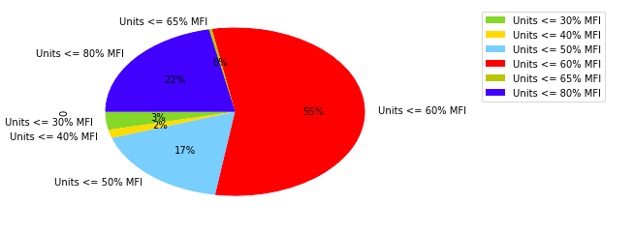

**How does the number of parks affect housing prices over the years?**

Description:

Although initially assumed that zip codes near parks would experience a greater increase in housing prices, this assumption was not demonstrated in the data. In fact, surrounding zip codes bordering neighborhoods with the most parks experienced a greater increase in housing prices.

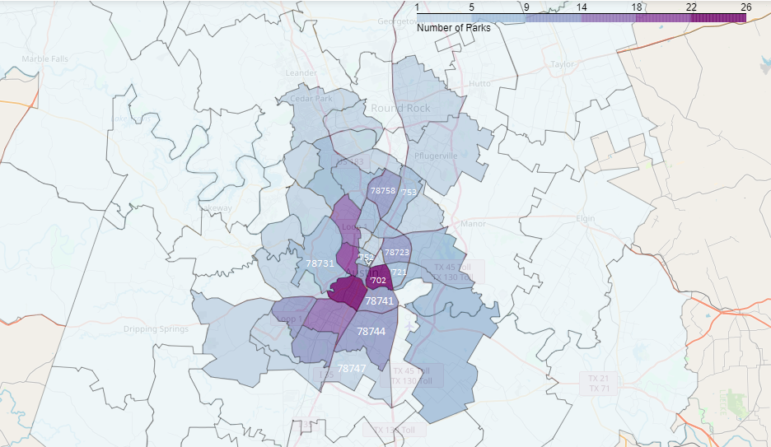

**How does crime affect housing prices over the years?**

Description:

The first top two graphs in the picture below isolate the type of crimes in each zip code. The lower graph visualizes the percentage change of crime rates in each zip code. In matching this graph to the housing price graphs, there is a general trend that zipcodes experiencing a decrease in crime experienced higher housing prices. This trend demonstrates the inverse relationship between crime and housing prices.

